Predicted changes in temperature in the UK
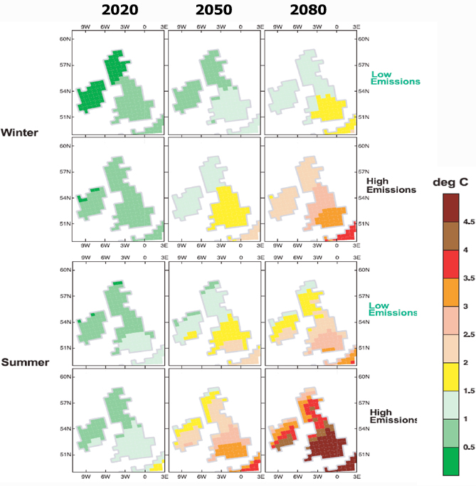

Source: UK Climate Impacts Programme
Predicted changes in rainfall in the UK

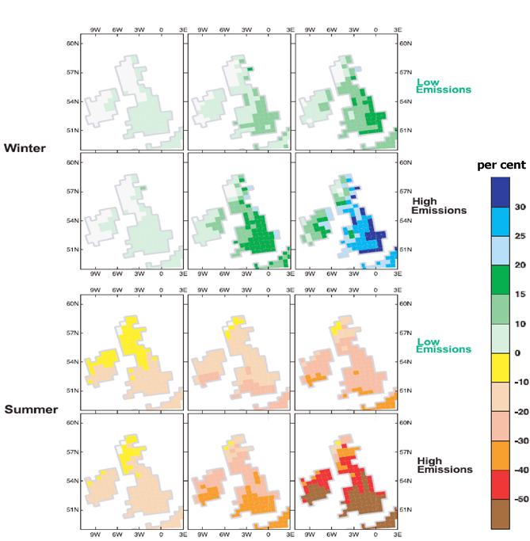
Source: UK Climate Impacts Programme
1. What will be the change in temperature in the summer of 2080 for the high emissions scenario where you live?

2. What will be the change in the amount of rainfall in the winter of 2080 for the high emissions scenario where you live?

3. Which places do you think will be affected most by climate change?

4. Which is likely to be affected the least?

5. How do you think they will be affected?

