Ecosystems
Follow-up resource 1: Analysing the data

Well done – you have collected soil and microclimate data for a number of different sites around your school grounds. It’s now time to look a bit more closely at the results and compare the sites.

Read the instructions carefully and complete the activities on this sheet.

Task 1

Look at the column on soil type. Write a paragraph to explain whether the soil type varies around your school grounds, and if so, how it varies.

Task 2

- On the diagram below, place arrows and labels to clearly mark the pH of the soils at each site.
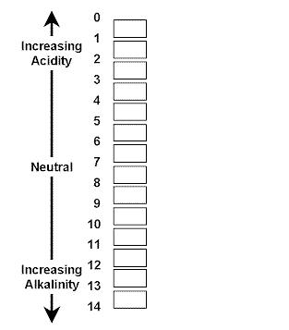

- Write a short paragraph to describe how the pH of the soils varied between different sites. (Extension: is there any link between soil type and soil pH?)

Task 3

- Complete the following graph to show how the infiltration rate of the soil varied between the different sites. Don’t forget to complete the axis.

Infiltration rate: Time taken for water level to drop by 1cm
(Seconds)

Site number

- Write a short paragraph to describe what your graph shows. (Extension: can you find any link between infiltration rate and the type of soil?)

Task 4

- Draw a series of bar graphs or picture graphs to compare the temperature, wind speed and direction at each site

- Write a short paragraph to describe what each graph shows.

- Extension: Try to make links between the different microclimate data you collected, and finish the following sentence starters:

- The affect of the wind speed on the temperature was…
- The affect of the wind direction on the temperature was…
- The affect of the aspect on the temperature was…

