Images for Starter Activity

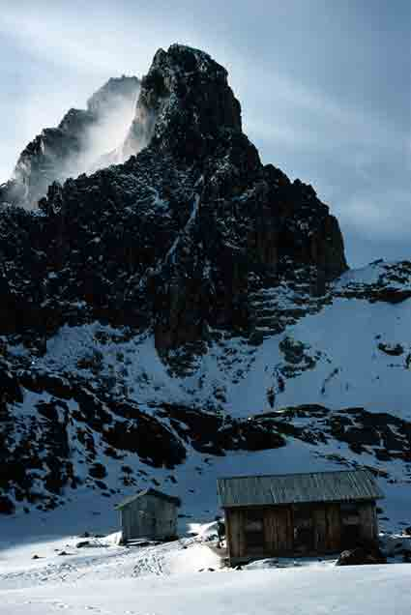
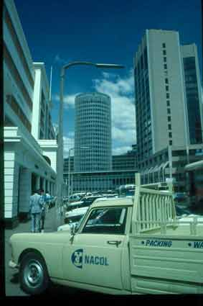
Mount Kenya © Martha Holmes
Central Nairobi © Cliff Pereira
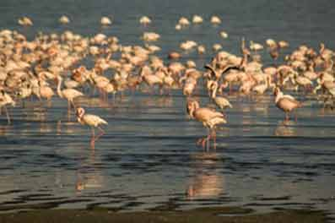

Greater Flamingos © Stephen Coyne

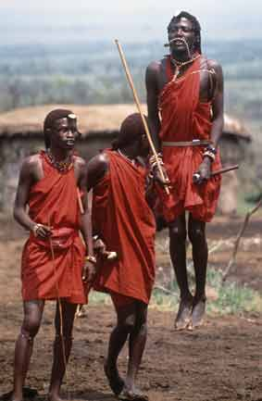

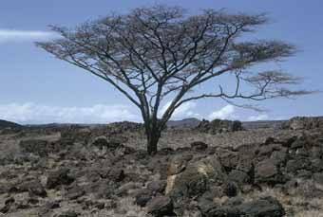
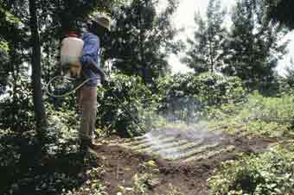
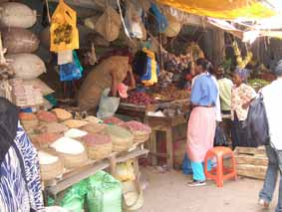
Spraying weed killer on crops © Adrian Arbib
Maasai Moran performing © Adrian Arbib

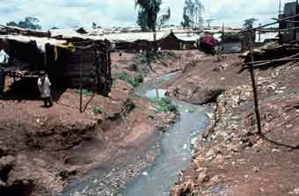
Acacia tree © Sybil Sassoon
A market in Lamu © Neil Williams

Dandora Shanty © Adrian Arbib

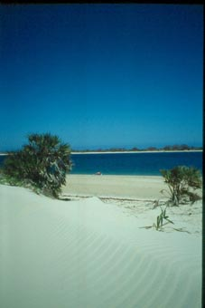
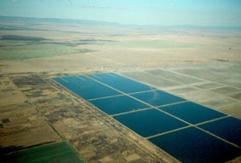

Fish farms © Cliff Pereira

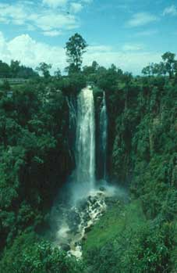

Shela beach © Cliff Pereira

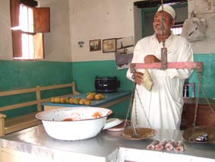
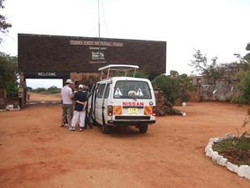
Halluwa seller © Cliff Pereira
Waterfall in central highlands, © Cliff Pereira
Tourists and driver at gate to Tsavo National Park © Cliff Pereira

